ABA/AARP Checklist for My Family: A Guide to My History, Financial Plans and Final Wishes (Paperback) $13
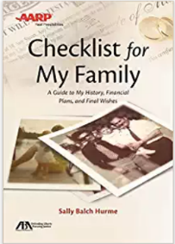
Put your life in order with this valuable new resource from AARP and the American Bar Association. Checklist for My Family guides you through the process of gathering in one place your finances, legal documents, online accounts, wishes about medical care, and more. Plus it tells you what you need, why you need it, what’s missing, and where to get it.
While giving you peace of mind, this book is also a gift to your loved ones. It spares them stressful decisions and needless frustrations when you’re ill or upon your death. And it presents them with your legacy, by providing specific knowledge of family history and recollections about your life, interests, and accomplishments.
Whether you choose to gather this critical information in the book itself or through the forms available free online, you can easily customize and organize your information.
With this one-of-a-kind guide, you’ll stay in control of your life and feel satisfied in knowing that if anything happens to you, you—and your family—will be well prepared.
Life.doc: Your Life Buttoned Up Ring-bound $100
Have you ever spent hours searching for some important paper or document? Have you ever worried that you wouldn’t have all of your critical information ready in the event of an emergency? We all know to expect the unexpected, so why not be prepared? Life.doc makes it easy and fun to organize your life. In just a few short hours Life.doc will guide you through the process of capturing all of your critical information so it is ready when you need it. Take it with you when you travel, put it in your emergency preparedness kit, or just leave it at home in your bookcase. No need to worry, Life.doc has been designed to capture your information safely and securely. Life.doc has 8 sections that encompass all of the critical areas of your life:
-Home Sweet Home Life.doc provides the template. You provide the information. So go ahead, give yourself peace of mind. Get started today! 120 pages plus accompanying CD-ROM
The Home Owner's Journal, Third Edition Spiral-bound $30
This is the book you've always needed to keep track of those home improvements! The Home Owner's Journal is the easiest-to-use home record keeping book on the market, and offers the homeowner the fastest and most efficient way to record important details. Have you ever forgotten the last time you had something cleaned, serviced or repaired? Have you ever purchased too little or too much paint because you didn't record how much you used the first time? Have you ever wondered which home improvements and repairs are tax deductible? This journal is your solution! It contains a chapter for every part of your home, inside and out. The Home Owner's Journal is a great gift for housewarmings, weddings, birthdays and for yourself.
The Home Owner's Diary Paperback $13
If you have an apartment, home, condo, townhouse, rental or vacation home, here is a comprehensive way to record all important details of your home purchases, maintenance, and improvements. Now you can keep track of all improvements made to both the exterior and interior of the house, including all yard work and maintenance. From details relating to security features, the utilities, and financial information i.e. insurance and warranties, this little book is invaluable for keeping all the important facts about your home in one place.
Home Keeper: The Ultimate Organizer Ring-bound $26
Getting your home in order has never been easier! Home Keeper is the perfect place to organize all your household information, including contacts for everyone from the contractor to the local hardware store, maintenance schedules, warranties, service contracts, records of repairs and improvement, inventories of art, collectibles, electronics, and appliances. And there's also space to help you organize household projects, to record ideas for future purchases, and store clippings and notes that you want to keep for inspiration.
Ideal for both the first time renter or buyer and the seasoned homeowner, it comes in a three-ring binder with 160 8-1/2 x 11" fill-in pages and 16 clear plastic sleeves for storage. Everything is organized by 8 divider tabs (each with a storage pocket) for simple, easy access, and with room to add your own materials. A beautiful addition to any home, this is the only home organizer designed in such an accessible and useful format.
What My Family Should know
Downloadable from https://www.state.gov/documents/organization/287513.pdf
Get it Together $17
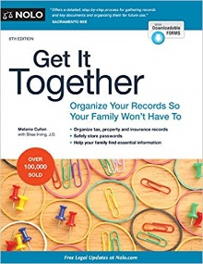
Everything you need to get organized. This workbook provides a complete system for structuring and organizing your information and documents into a records binder. For each topic, you will find helpful content, rich resources, and step-by-step instructions.
Also, available: A companion Binder & Tab Set, by Melanie Cullen. To purchase, search for "get it together binder and tab set." Do your loved ones know where to find your life insurance policies, online banking passwords, real estate deeds, or even your will?
If you’re like a lot of people, you keep important information―from the whereabouts of family heirlooms to online passwords to automatic bill-pay details―in your head or stashed in the odd desk drawer. Unfortunately, this disorganization will likely cause hassles for those who someday take care of you or your estate.
All forms are downloadable through a link printed in the book.
Homeowner's Record Keeper: The Perfect Place to Keep Track of Home Repairs, Maintenance, Plans, and Dreams $2
This workbook is an indispensable aid to the preservation and improvement of the investment that is your home. keep track of home records and maintenance schedules, prioritize repairs and improvements, and sketch out concepts and proposals for future projects. Appropriate for first-time buyers as well as seasoned homeowners, the Homeowner's Record Keeper will help you enjoy your home for years to come.
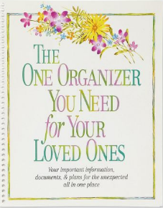  Organizer for Your Loved Ones $8  Organize the important papers, policies, and information your family will need. Spiralbound, 8" x 10" softcover book includes 18 fill-in/info pages plus 4 pocket pages for documents. | When I'm Gone Planner $20  Fill-in record book lets you leave instructions about your will, insurance, and last wishes, plus children, pets, and day-to-day details. Hardcover, 144 pages; 10-1/4" tall.

